ENMT301

# Conceptual Design Report

Liam Hare (27686710)

James Krippner (18114622)

Zeb Barry (7931379)

Table of Contents

1.0 Executive Summary 3

2.0 Introduction 4

3.0 General Specifications 4

4.0 Design Space and Concept Generation 5

4.1 Equipment 5

4.2 Concept Strategies 5

4.21 Continuous pick up of all weights 6

4.22 Intelligent Movement and Fast Sorting 6

4.23 – Third concept strategy 6

5.0 Proposed Concepts 6

5.1 Concept 1 – The Inhaler 6

Description 6

Construction 6

Target identification 6

Target collection 7

Turbine 7

Storage mechanism 7

Maneuverability 7

5.2 Concept 2 – The Sorter 8

Description 8

Body Design 8

Navigation 8

Package Collection 9

5.3 Concept 3 – The Magnet Gantry 9

Description 9

Body Design 9

Navigation 10

Target identification 10

Target Collection 10

6.0 Concept Evaluation 10

6.1 Concept 1 Evaluation – The Inhaler 10

6.2 Concept 2 Evaluation – The Sorter 11

6.3 Concept 3 Evaluation – The Magnet Gantry 11

Concept Comparison 11

Conclusions and Recommendations 11

Appendices 12

## 1.0 Executive Summary

## 2.0 Introduction

The 2019 Robocup involves designing a robot within a team of three 2nd year Mechatronics students at the University of Canterbury. This robot will compete against another robot to navigate around a given arena and collect two of three weights within a two minute time limit. If the robot collects all three weights, then the opposition will be declared the winner. The weights are 0.5 kg, 0.75 kg and 1 kg respectively. They are cylindrical in shape with a groove near the top to ease collection. Among these weights are a collection of ‘dummy’ weights, constructed identically out of plastic. This report outlines the conceptual design process undertaken to develop three different concepts that were evaluated and compared, with recommendations made for a final design.

## 3.0 General Specifications

These specifications describe the minimum requirements in order to qualify and compete in the competition, outlining various safety, environmental and competitive constraints in order to be successful.

1. Functional
   1. The robot must be fully autonomous.
   2. The robot must be able to distinguish the target weights from the walls and obstacles (including the opposition robot).
   3. The robot must be able to navigate through a 400 mm gap.
   4. The robot must be able to drive over or avoid 25 mm high speed bumps and 100 mm high ramps.
   5. Minimal dependencies between components of the system i.e simply = better
   6. The robot must be able to pick up weights that are against the wall or in a corner.
   7. The components of the robot should be easily interchangeable to allow repairs and maintenance to be performed efficiently
2. Performance
   1. The robot should be able to move quickly about the arena – at least 0.5 m/s.
   2. The robot must have a gradual speed profile, not just full speed.
   3. The robot should be able to collect a weight without having to stop for longer than 15 s.
   4. The robot should have informed movement control, not just turn right when it hits a wall.
   5. The robot must be able to collect 1 kg horizontal or vertical weights.
   6. The robot must be able to collect and hold at least 1.75 kg of weights.
   7. The robot should be able to distinguish plastic weights from brass weights.
   8. The robot should be able to collect dummy weights and brass weights.
   9. The robot must be able to operate for at least 2 min without running out of battery.
3. Safety
   1. Lasers must be below 5mW.
   2. Spinning devices must travel at under 200rpm, unless sufficient guarding is in place.
   3. The cut off module must be used between the battery and any electronics.
   4. Must not produce naked flames.
   5. Must not use chemically explosive or EMP devices.
   6. The voltage within the device must not exceed 100V.
4. Constraints
   1. The robot must be controlled by the Arduino Mega ADK
   2. In addition to the supplied components a maximum of $50 may be spent on additional parts.
   3. 200g of material may be used for 3D printing. Additional material will come out of the $50 budget.
   4. Both robots must retain inside the arena at all times. If the robot ventures outside the arena, whichever robot is responsible will be disqualified.
   5. The robot must not have the ability to deliberately damage another robot.

## 4.0 Design Space and Concept Generation

### 4.1 Equipment

Before concept generation, the supplied components described in specification 4.2 were outlined, below in **Table 1**.

**Table 1**: List of supplied materials and equipment

|  |  |  |
| --- | --- | --- |
| Right Ang Al – 25/12 mm | 2 x Track | 4 x Standard Servos |
| Box Section Al – 12 mm | 4 x Laser cut supports | 1 x Geared Stepper Motor |
| U Section Al – 12 mm | 6 x Open Beam – 240 mm | 2 x Stepper Motors |
| Flat Bar Al – 25/12 mm | 6 x Open Beam – 120 mm | 8 x Micro Switches |
| Round Bar Al – 8/6.5 mm | 6 x Open Beam – 20 mm | 2 x Inductive Sensors |
| 8 x Bearing Assembly | 2 x DC Drive Motors | 1 x Long Range IR Sensor |
| 2 x GT2 Timing Belt | 4 x Geared DC Motors | 2 x Med Range IR Sensors |
| 2 x GT2 16 Teeth Pulley | 4 x Smart Servos | 4 x Short Range IR Sensors |
| 1 x Arduino Mega ADK | 2 x Small Servos | 2 x Var Range IR Sensors |
| 1 x Battery Protection Circ | 1 x IR Position Camera | 6 x Sonar Sensors |
| 1 x 4000mAh Li-Ion Battery | 1 x Weight Sensor | 2 x IR Interrupt Sensors |
| 2 x Load Cells | 1 x Inertial Measure Unit | 2 x Digital Interface Circ |
| 4 x Perspex 300x300x5 mm | 2 x Analogue Interface Circ | 2 x Relays |
| 1 x Perspex 300x300x10mm | 2 x Main Body Side Panel | 1 x Flat Body Panel |
| 2 x Perspex 300x300x2 mm | 1 x 12V DC Electromagnet | 2 x Voltage boosters |

### 4.2 Concept Strategies

The 2019 rules turn the competition into a race with a limited time of two minutes and only three metal weights up for grabs. In order to win the round a robot must collect two (but not three!) weights within the two minute time limit. The following strategies were created out of group discussion and brainstorming. The available parts were looked at and investigated to stimulate the ideation process and previous robots were studied to analyse what strategies and concepts would be the most successful. This was found to be a very effective method as it generated a large number of very different ideas that could then be reduced into the three strategies below through constructive feedback within the group and discussion of the advantages and mistakes of previous robots.

#### 4.21 Continuous pick up of all weights

This strategy hopes to effectively meet the rules of the 2019 Robocup by making the robot fast and simple. A continuous pick up mechanism saves time by minimising stopping and starting. The ability to pick up all weights hopes to work in the favour of the sensors available. The sensors that have the ability to distinguish between metal and non-metal have short range therefor if the robot has to get close to the weight before determining if it is metal or non-metal than it might as well pick it up as no penalty is awarded for this.

#### 4.22 Intelligent Movement and Fast Sorting

This strategy intends to quickly and efficiently identify and collect the weights by using an aggressive scanning approach. Using this instead of randomly or grid searching the arena will theoretically reduce the time taken to find the weights and thus beat the other robot to collecting two weights. The robot will also need to quickly sort out whichever weights it encounters. The first weight it finds should be collected, even if it is a dummy. This is because if the other robot does not collect any weights then collecting a dummy will win the round. However, if an actual weight has been collected, all dummy’s will be ignored.

#### 4.23 – Third concept strategy

## 5.0 Proposed Concepts

### 5.1 Concept 1 – The Inhaler

##### Name

#### *Description*

This concept exercises the continuous pick up strategy as explained in section #. The robot implements a random search algorithm to determine initial movements until a target weight or dummy weight is identified. A large storage area aims to provide the ability to also consume dummy weights to eliminate the need to avoid them and also to utilize the strengths of the sensors provided.

*Target identification*

Medium range IR sensors are positioned higher than the weights and sense the presence of walls and obstacles. The large ultrasound sensor is comparatively positioned low on the robot and detects the presences of both dummy weights and target weights. The signals produced by the IR and ultrasound sensors are compared to determine if there is a target or an obstacle present.

#### Target collection

If a target is identified, the robot will continue moving over the target. The target will be guided with angled Perspex towards the side of the turbine where it will be hit into the collection trailer. As the target is guided, an inductive sensor will determine if the target is a dummy weight or a metal weight. When two metal weights have been detected the robot will stop.

#### Turbine

The turbine will be constructed of a single piece of rubber that will need to be purchased. The DC motors will spin the turbine in conjunction with the wheels. A *mechanism will only allow the turbine to spin one way to prevent complications when reversing or turning.

#### Storage mechanism

**Figure 1**: Concept 1 - Rear View

The aluminium trailer can store up to four weights. The weights enter the trailer on one end and then due to a slight slope, the weights roll to the opposite end to make room for the next weight. The trailer has wheels to prevent the robot from getting stuck on obstacles.

#### Manoeuvrability

A gyroscopic sensor is used to determine if the robot is being affected by an obstacle such as a ramp and will initiate a reversal state to remove itself from the situation.



***Figure 2:*** *Concept 1- front view where the green boxes represent sensors and the red component is a geared DC motor that rotates the brown paddle.*

### 5.2 Concept 2 – The Sorter

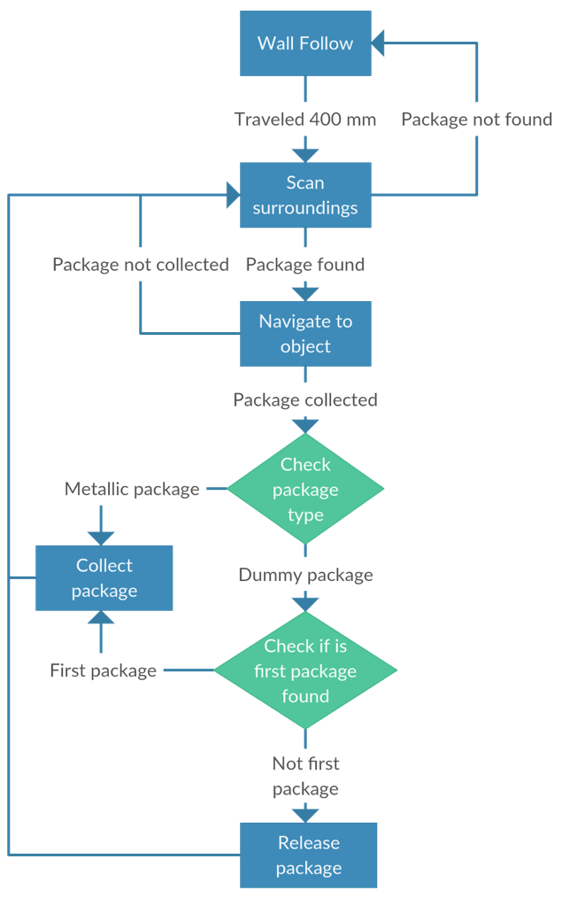

**Figure 3**: Finite State diagram of The Sorter's search algorithm.

##### Zeb Barry

#### Description

The Sorter outlines the intelligent movement and fast sorting strategy outlined in section 4.22. A wall following techniques is used to navigate the arena, occasionally completing a 360 degree spin to scan for weights. Once a weight is detected, it is collected and the process repeats. A finite state machine diagram is shown below in **Figure 1**.

#### Body Design

The body of the robot is constructed of the materials provided. It utilises the side panels and 240 mm open beams to hold it together. The Arduino and battery are located out of the way at the top of the robot, mounted on a section of 2 mm Perspex supported underneath by open beams. The motion of the robot is controlled by the two geared DC drive motors on a toothed pulley that drives the track. The track then runs over two large 3D printed 140 mm wheels. These wheels allow the robot to sit 35 mm above the ground, avoiding beaching on the speed bumps.

#### Navigation

The robot navigates its environment using a combination of short and medium range infrared sensors. These are mounted a 100 mm and above to avoid detecting the weights, while still detecting ramps and walls in the arena. It uses these sensors to inform a wall following algorithm that Pauses every 400 mm to complete a 360 degree rotation, scanning for weights. With a dead zone of 60 mm and 150 mm, for the short and medium range sensors respectively, the sensors will be set back this distance within the robot. This means that their field of view will start at the edge of the robot, removing any blind spots. Two short range sensors will aim out each side of the robot, while one the two medium range sensors will aim forwards from either side of the robot. Two more short range sensors will angle outwards at 45° from forwards. The combination of all of these sensors will provide a robust navigation system, with a clear 180° view around it.

#### Target Identification

In order to identify weights, two IR lasers emit light a flat plane at 50 mm and 120 mm above the ground. An IR positioning camera detects IR light reflected back off the weights in the arena, due to their metallic, shiny finish The camera then returns a 2D grid of the co-ordinates of the four brightest spots in its vision. The algorithm then reads this data and determines if there is a weight in the surrounding area, navigating to it if necessary. Although the camera only has a 33° field of vision, the full rotation of the robot every 400 mm eliminates this limitation, providing a full field of view.

#### Target Collection

The Sorter utilises a fast collection and sorting method for weights. It uses a Perspex sheet rail system to channel the weights to the centre of the robot where a flat aluminium bar, controlled by a servo, holds them in place. An inductive sensor then determines if it is a weight or a dummy, either directing it to the side for collection or allowing to pass completely underneath the robot. A limit switch is used at the proximity sensor to determine when a package has entered the robot and thus to sort it. As there is no penalty for collecting a dummy weight, and can potentially provide an advantage if the opponent is unable to collect any weights, the first dummy encountered is collected. As the robot is able to keep moving while these weights are sorted and collected, it reduces the time that the robot is stationary, and thus increase the potential to identify and collect more weights. This rail system is shown below in the CAD model of The Sorter, **Figure 2**.

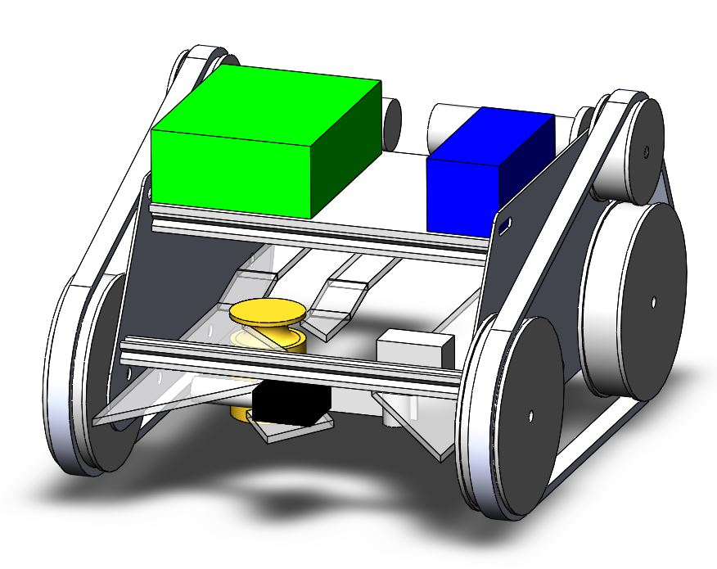

Figure 2: Concept 2 - The Sorter

**Figure 4**: Concept 2 - The Sorter SolidWorks model

### 5.3 Concept 3 – The Magnet Gantry

##### James Krippner

#### Description

Concept 3 employs an offensive strategy that ignores the plastic weights. Its design makes it more difficult for opposing teams to pick up the weights by knocking them over, meaning that even on failure to pick one up it has more chance to try again.

#### Body Design

Tunnel aligns weight with magnet.

Bridge knocks them over.

Standard pulleys, frame pieces

#### Navigation

#### Target identification

IR sensors are used for target identification. An array of IR sensors is placed on both the left and right sides of the robot. Each array utilises the provided short and medium range IR sensors, pointing inward to form an overlapping detection zone. The short-range sensors are mounted approximately 30 mm above the ground - such that they will detect both targets and obstacles – and the medium range sensors are mounted approximately 80 mm above the ground - such that they will only detect obstacles. This allows the output of both sensors within each array to be compared, and if the short-range sensor is showing a smaller reading a target must be present, allowing the robot to align itself with the target (by matching the readings of each array) and drive it into the tunnel.

A capacitance sensor is placed at the magnet pickup point to determine whether the target is a plastic ‘dummy’ weight, or the desired metal weight. If the desired weight is present, the pickup routine is activated.

#### Target Collection

Magnet activated

Lead screw actuates the magnet upwards to clear weight barrier.

Magnet actuated along y axis on gantry, to the left or right container depending on presence of other weight.

## 6.0 Concept Evaluation

### 6.1 Concept 1 Evaluation – The Inhaler

Robustness(strength)(will it break down): There are not many intricate mechanisms and so failure without external influence is low.

Reliability(how often can it be expected to make a mistake when everything is working): The random search method will prevent the robot getting stuck in a loop. The turbine speed is dependent on the ground speed of the robot and therefor may be spinning too slow if the weight is near a wall preventing enough force to push the weight onto the trailer.

Target identification: The robot only distinguishes between obstacles and weights which is simpler than the other designs. However, the robot is unable to distinguish between a target and the opposing robot as required in R1.2.

Maintainability and construction: Simple design with good access to components.

Speed (ground speed and collection speed):

Strategy:

Maneuverability:

### 6.2 Concept 2 Evaluation – The Sorter

##### Zeb Barry

### 6.3 Concept 3 Evaluation – The Magnet Gantry

##### James Krippner

A disadvantage of this collection mechanism however is that it required the weights to be sufficiently far from the walls of the arena to allow the robot to move over them.

### 6.4 Concept Comparison

6.41 Cost

6.42 Power Consumption

|  |  |  |  |
| --- | --- | --- | --- |
| Component | Concept 1 | Concept 2 | Concept 3 |
| DC motor |  |  |  |
|  |  |  |  |
|  |  |  |  |
|  |  |  |  |
|  |  |  |  |
|  |  |  |  |
|  |  |  |  |

6.43 Dynamic Ability Estimations

Compare weights

Note that concept one will carry more weight potentially due to excess dummy weights though this will not affect the manoeuvrability.

6.44 Overall Concept Evaluation

|  |  |  |  |  |  |  |  |
| --- | --- | --- | --- | --- | --- | --- | --- |
| Factor | Weighting (/10) | Concept 1 Scores | | Concept 2 Scores | | Concept 3 Scores | |
| Mechanical  Complexity |  |  |  |  |  |  |  |
| Software Complexity |  |  |  |  |  |  |  |
| Speed |  |  |  |  |  |  |  |
| Reliability |  |  |  |  |  |  |  |
| Robustness |  |  |  |  |  |  |  |
| Manoeuvrability |  |  |  |  |  |  |  |
| Searching  Algorithm |  |  |  |  |  |  |  |
| Dummy weight pickup |  |  |  |  |  |  |  |
| Pickup flexibility |  |  |  |  |  |  |  |
| Maintainability |  |  |  |  |  |  |  |

## Conclusions and Recommendations

## Appendices